RARE DISEASE DAY 2023

Summary of the day and next steps

‘Nothing about us Without Us’

INTRODUCTION

Living with a rare disease can be extremely challenging, both physically and emotionally. Because these conditions are rare, they often go misdiagnosed or undiagnosed for long periods of time, leaving patients without proper treatment or support. Additionally, rare diseases often lack effective treatments or cures, leaving patients with limited options for managing their symptoms and improving their quality of life. Patients with rare diseases may also experience social isolation and stigma due to their condition, as well as financial burdens associated with accessing specialized care and treatments.
Living with and supporting individuals and families with genetic, undiagnosed and rare disease poses many challenges but also opens the door to opportunities. The way we harness these opportunities will define the rare disease sector's future.

Living with a rare disease can be a complex and difficult experience, and requires a strong support system and access to specialized care in order to manage the physical and emotional toll of the condition.

The potential for the future
The future of care for rare diseases looks promising with advances in technology and research and critically a patient-centric approach
- Patient-centered research: Patient-centered research involves involving patients in the research process, including setting research priorities, designing studies, and interpreting results. This approach can ensure that the research focuses on the needs of patients and can lead to more effective treatments.
- Telemedicine: Telemedicine has become increasingly popular due to the COVID-19 pandemic. For rare disease patients, telemedicine can provide access to specialists who may not be located nearby. This approach can also help reduce the burden of travel and time away from home.
- Drug repurposing: Drug repurposing involves finding new uses for existing drugs. This approach can potentially speed up the development of treatments for rare diseases, as the drugs have already gone through the regulatory process for another indication.
- Precision medicine: With the advent of precision medicine, treatments can be tailored to an individual's genetic makeup. This approach could lead to more effective treatments for rare diseases.
- Gene therapies: Gene therapies have shown promise in treating rare diseases caused by a single gene mutation. In some cases, they can offer a potential cure. As the technology and research in this field advance, more rare diseases may become treatable with gene therapies.
Working in rare disease can be overwhelming and isolating as we hone in on solving the problems of our individual small communities. There is a need to provide the right infrastructure and resources to allow patient organisations to thrive no matter their size. We need to move away from survival mode (ad hoc funding and limited resources) and work collaboratively.
The recent UN Resolution states that
‘It is the right of every human being, without distinction of any kind, to have access to the enjoyment of the highest attainable standard of physical and mental health and to a standard of living adequate for the health and well-being of oneself and one’s family.’
In recent years the needs of rare disease have been amplified and we are on the precipice of real change through acknowledgement and investment and the advancements in medical science and technology. However, as it stands there are inherent inequities that we need to overcome.
There such a broad range of issues and challenges for people living with rare disease that it makes sense to utilise the rare disease sectors collective strengths. There are limited resources and we do not want to compete within our sector, but rather work collaboratively to avoid repetition and duplication. Each state, organisations or individual in this sector bring a different perspective, broadening our perspective. Each needs the opportunity to be a public voice and drive the changes needed to have a real impact on rare disease patients and their families.
We need to work collectively and collaboratively, more voices provide diverse opinions, and solutions. If we are to lead with the notion of leaving no-one behind and ensuring nothing about us without us, then it’s a community challenge not one state, organisation, condition or family at a time.
Some states and rare disease patient groups are better resourced than others, and when groups work in isolation, or even feel isolated, it does not serve people and families who’s quality of life is being compromised on a daily basis.

Every voice matters.
Yours and ours – individually and collectively.

Rare Disease Day Morning Presentation Highlights

Richard Vines
Richard shared this experience in founding the National Oncology Alliance and focussed on the importance of clarity of purpose and working in positive collaboration.
Alison Archibald
Ali presented the collaborative nature of the Mackenzie’s Mission project and shared with us the process of building out engagement and collaboration. Starting small and simply and then expanding with purpose.
Carla Carroll
Carla shared the Genomics Industry Alliance journey and challenged us to think honestly about collaborations and alliances, be transparent and seek to understand strengths and challenges to build on and address
Tiffany Boughtwood
Tiff conveyed the Australian Genomics experience and reminded us that we are part of a dynamic environment, one that requires us to be agile and prepared to evolve to meet the challenges and opportunities an alliance can bring.
Nicky Conway
Nicky created a shared understanding of co-creation and co-design. This involved exploring some existing models and principles. This provided a perfect foundation for our workshop.
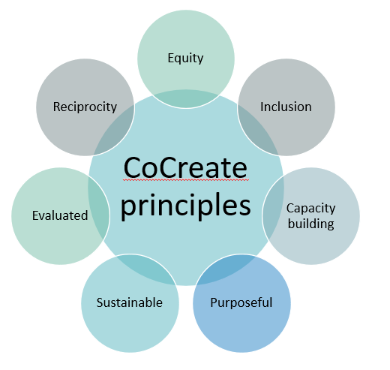

The Workshop: How to collaborate to deliver for future needs to our communities.

This discussion/workshop was focussed on exploring and understanding our communities needs for a collective/collaborative/alliance that may can combine to overcome our challenges, be heard, influence policy and practice, learn what we need to know.
It’s hard to find the time or the energy to fight the fight, engage in that consultation, respond to that request, write that letter or submission, or even make that phone call. Despite this, we want and deserve a voice, to be active and proactive where our lives and the lives of our rare disease communities are impacted.

This section captures the discussion of the workshop including elements which have informed the proposal. To reflect the co-create process sentiments expressed have not been curated but left as said to reflect the essence of the discussion.

Opening discussion on the current Rare Disease environment

- Australia has a National Strategic Action Plan for Rare Diseases.
- We need to build on and leverage the success of others as partners.
- Science and discovery are dynamic – it’s an evolving environment
- Current environment is non-inclusive – it’s the same voices and they are not always inclusive or representative of all patients and their families needs.
- There are some organisations that claim to be peak bodies and represent the community, but in reality, this is not the case and little engagement and consultation takes place. And often, there is a membership fee involved which is not always financially viable for small grass roots organisations supporting families on a needs-based level.
- As the knowledge of rare disease is expanding it is challenging to maintain an inclusive and representative environment. The diverse needs of the people affected by rare disease need to be heard individually and collectively, and this brings considerable challenges.
- Acknowledgement is needed that we, the patient community, are the experts in how the technology needs to be translated to improve lives.
- Unfortunately we are often not included in discussions and decision making that impact our care at an individual level or as a group or community.
- Our voice is not always valued – including through reimbursement. For example many times the only people not being paid for their time in a consultation process is the patient or carer, and they had had to pay for care of their child or dependent and/or take leave from work to actually be in that consultation.
- We do not have a level playing field – improved quality of life is not accessible for everyone and every condition, pathways to change are inequitable. This is evidenced across many (maybe all) rare conditions and across the states. There are also variances in the delivery of care across metro, regional and remote areas.
- Patient centred care has not changed the patient or family experience – patient led care and decision making has not yet arrived.
- Accessing paid work for people with rare diseases is a challenge.
- There is a Duty of Care that sometimes seems not to be there.

The challenges of collaboration:

- Collaboration across organisations is needed to avoid duplication of events, projects and engagement
- How is any alliance created going to be different from what exists – specifically Rare Voices Australia already provides advocacy for rare diseases.
- It will be challenging supporting individual voices as well as patient support groups – identifying and understanding individual and common challenges
- For the survival of smaller Patient Support Organisations who support very rare or small communities, they may need tobe part of an ‘alliance’.
- Establishing what the ‘system’ needs to look like – not just health but also NDIS and education.. Where are the gaps that an alliance could focus on.
- One size doesn’t fit all.
The group discussed how this could be done:
- Establishing a thematic focus with tactical deliverables – communications
- Be inclusive of multi-disciplinary expertise
- Engage with other alliances – e.g. Rare Voices Australia, Patient Voice Initiative, Consumer Health Forum, and share intelligence, resources and support
- Become a bridge to and between stakeholders
- Be inclusive of multicultural and diverse voices
- Include the whole life course – understand the patient journey and the gaps/pain points as patients and families are making the journey
- Ensure access/inclusion of stakeholders including health professionals and industry
- Ensure a collective effort to leverage genomic advances for everyone
- Develop and share case studies
- Develop and share a ‘basic’ basket of needs
- Connect ‘grassroots’ experience to support the needs of the community

The focus of future collaboration

It was acknowledged that this is the easiest area to discuss as there is much to be done to positively impact quality of life.
Areas of focus included:
- Registries
- Clinical Trial Access
- Grief and loss
- Survival and being a survivor
- Integrated systems including allied health
- People ageing with rare conditions
- Being inclusive of all people
- Roadblocks in the health and support systems that impact access to care and treatment
- The translation gap – actually ensuring change through research funding implementation
- Prioritisation of issues with agreement and a common purpose
- How do we support and influence the challenges – once identified
- Mental health and wellbeing
- People living with disability and their families
- Access to services and support – health, mental health, education and disability including NDIS
- Building a more collaborative environment

This included considerations:
- Focus on similarities rather than differences across conditions
- Inclusive of families and carers
- Every step of the patient journey – pain points and barriers

Workshop Conclusion

Thank you to all our participants on the day and contributors. We valued the open and honest dialogue and acknowledge that is sometimes not easy to discuss such personal topics and be vulnerable in an open forum, so we very much appreciate the deep discussion.
We learnt so much from our workshop discussions and it was agreed that, despite the current advocacy and support resources available to our communities in various forms, a ‘grassroots’ alliance based on co-create principles would be a valuable resource for our communities.
The foundation purpose for this community led ‘entity’ is how we drive optimal quality of life, how we put our health and wellbeing at the forefront of decision making.
This is about creating a ‘grassroots’ mechanism, a way of exploring health and well-being decision making ‘of the people, for the people, by the people’ as Abraham Lincoln once said when describing democracy.
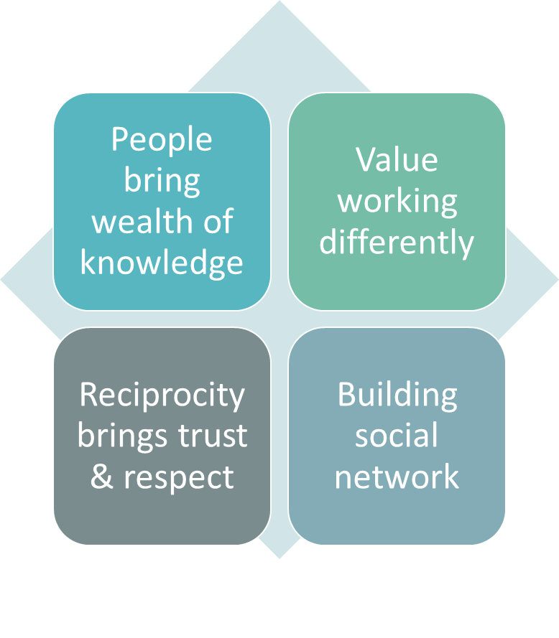

NEXT STEPS: Forming an Alliance

This is an open document for comment, feedback, recommendation.
Please provide your feedback and guidance on the following

It’s a beginning based on the co-creation which occurred as part of the workshop, which is exciting and the opportunities and possibilities are within reach if we can build on the shared wisdom of our presenters and our own community expertise.
To be a successful Alliance, we need
- a common purpose
- to start small and build out to include all stakeholders
- to be transparent, inclusive and courageous
- to be agile and dynamic and prepared to evolve
- to listen and explore, working with and for our community together
- to be of value to our community and our stakeholders
- to minimise workload on community (avoid duplication and improve learning from each other)
- commitment and resources to fund our mission

GSNV proposes the next steps to establish an alliance:

Establish a rare disease Alliance with aligned purpose

The essence of the alliance is that its is:
- A grassroots community-led – the community decides who, what, when and how
- Our communication and engagement are totally accessible and multi-modal
- Everyone is welcome and their input valued
- We work off the principle of co-create, co-design and co-produce in all activities – we talk about things together and agree on the way forward
- We don’t duplicate
- Contribution is optional
The next steps in establishing the alliance include:
- Identify all stakeholders - so we know we are including as many as possible in the next steps.
- Determining the principles of Network/Alliance
- Establish timelines and key events to help shape future development of the alliance
Build the appropriate Governance by ensuring:
- Develop Terms of Reference
- Align on a Alliance Structure which will probably need a core governance group who have oversight across the dialogue and action elements of the network/alliance.
- Agree on critical governance which ensure transparency and accountabilities:
  - Planning: An agreed annual plan including a stakeholder engagement strategy which is clear, transparent with accountability
  - Reporting: Annual reporting on all activities and shared with our community and policy makers
This includes a method of sharing information that makes it accessible to participants, transparent and supports accountability.
The GSNV will provide initial secretariat functions for the network/alliance to support the establishment phase.

Development of the Alliance

It is proposed that the alliance develop 2 streams of activity to inform there future:
- Difference Dialogue
- GUARD Action

- Difference Dialogue
Purpose: To provide opportunity for the community to come together and talk about common areas and issues of interest. This may or may not lead to action.
This stream will focus on facilitating dialogue and community expectations around national issues of priority for our community.
Topics covered will be wide-ranging and inclusive of strategic planning, logistics and operations what is covered will be depending on the stream and the topics within the stream.
- Develop a ‘community’ understanding
- Sharing learnings, thoughts and priorities
- Targeted and facilitated to engage in formal consultation
- Strategic planning

Dialogue will lead to action which will be determined by the community.
Proposed Dialogue topics
- Carrier Screening Implementation
- Newborn Screening – Community Expectations and priorities
- Gene and Cell Therapy Advancement
- Ageing with a rare difference
- HTA reform contribution
- Clinical trials and treatments

Difference Dialogue Methodology
Topic areas will have a dialogue lead – this will occur on a voluntary basis with a self-nomination to lead.
Leads will then develop the engagement strategy most appropriate to the topic.
Some topics will need more information sessions to ensure everyone can contribute and comes to the conversation at the same level of understanding, where others may begin with solution-based workshops.
Delivery mechanisms include: webinars, zoom meetings, face to face meetings, closed Facebook groups, website forum pages

- GUARD Action

Dialogue may demonstrate the need for collective action or identify individual pathways.
Agreed community led actions will be developed into activity plans and execution strategies developed and agreed.
It is envisaged that these actions may include:
- Advocacy – supporting local and national campaigns.
- Consultation and contribution to Submissions
- Development of community tools, templates and resources
- Development and implementation of a stakeholder strategy around a particular issue or course of action.
The community will determine the terms of engagement and action strategy and plan including the stakeholders to be engaged and when.

https://www.health.gov.au/resources/publications/national-strategic-action-plan-for-rare-diseases

